A Study on Big Data Application in Animated Characters

Young-Suk Lee

* Institute of Image and Cultural Contents, Dongguk University,
Seoul, Republic of Korea

E-mail: tonacoco@dongguk.edu

Abstract
This paper studied utilization values of big data in the character field. Characters as an important factor in digital contents take a great part in cultural contents. Construction of big data in the character part will predict the future of the field of character industry and decrease risks of production costs and also be a basis in character development.
Keywords— Big Data Application; Character; Animation

Introduction
Recently, a thing that appears the most in economic trends including IT industry is big data. It means a large scale of data difficult to be saved, controlled, and analyzed in existing methods. It is a vast stock of data which has not been treated in existing methods and signifies using information which has been hidden in enormous data owing to analysis technology development. If big data is used, it is possible to forecast the future from capturing regular flows of data[1].
As big data is stated, it was pointed out as ‘the most important technology of 2012 which can open new possibility’ in the World Economic Forum (Davos Forum) in 2012[2].
Regardless of the growth of the big data market, a point that common understanding of characterizing of factors fitting to the concept of big data is lacking was indicated[3]. And, about contents and results of big data, analytic visualization and utilization were proposed. Like these, although studies on big data have been done steadily since the introduction of big data, studies related with character development in the fields of big data and animation never exist.
In this study, possibility to graft big data on the character market has been examined. Based on it, the utilization of big data is to be suggested so that it can be applicable to later studies and technology development.

Related Work
Big data is available in various fields such as image analysis, trend analysis, crisis management, and storytelling tools. Parse.ly as an enterprise to analyze web contents in the US predicts what types of contents will be promising through a program called “Dash”. If editors use the analysis tool of Parse.ly, they can know what things of what websites can draw interests of viewers and classify objects of interest according to authors, subjects, genres, introduced websites, trends of emerging frequencies, and other indexes[4].
Through these, big data will take groundbreaking changes in the publishing field. It shows extensibility about the necessity of big data in other fields. Characters play an important role in digital contents. Characters in the animation field have diverse forms and characteristics.

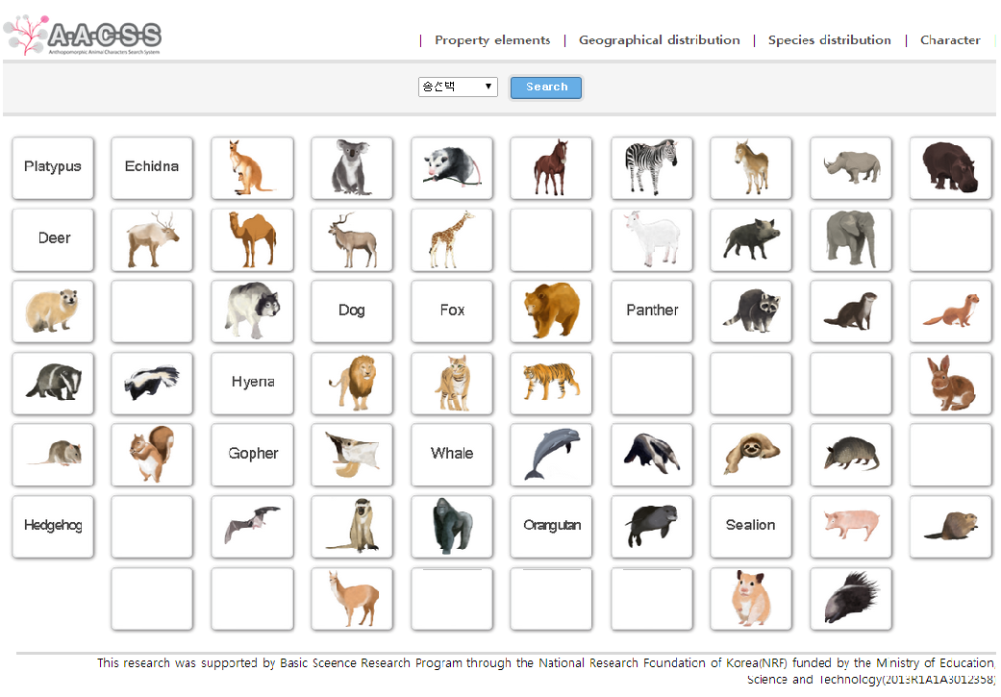
- AACSS Main UI.

Especially, in case of characters that animals appear, they became big hits.
As studies on characters of personified animals, there are researches to propose anthropomorphic animal characters search systems (hereafter, AACSS) in order that users can be possible to search for them by using meta data based on studies which suggested steps of anthropomorphism reflecting properties of animals and humans(Fig 1)[5][6]. Based on them, this study tries to branch out into mammals and birds.

Big Data Application in Animated Characters
It is a base study on constructing big data systems of personified characters. As the study range, it is on the basis of taxology targeting mammals and birds which emerge in full-length animation.
Zootaxy is learning to research classification systems of the animal kingdom after investigating similarity and difference between animals based on facts. Taxology has been started from Aristotle of Greece. He assorted approximately 520 animals according to their characteristics first. By the 18th century, Carl von Linne set up class, order, genus, species, and mutation as taxonomic categories.
Mammals are divided into four parts of a head, neck, torso, and tail. The torso is composed of four legs. Sometimes, mammals have a peculiar component like horns. Birds are divided into four parts such as a head, neck, torso, and tail as well. They have two wings and legs. The front legs have been adapted to flying mostly. On the other hand, the hind legs have been adapted and changed into various directions. Among external properties of birds, in particular, a predominant trait is called “field mark”.
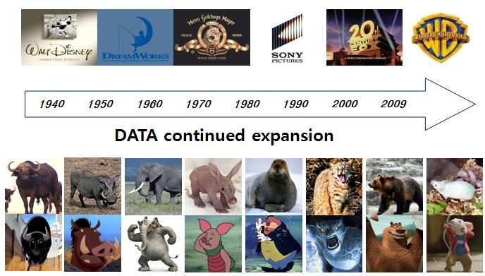
- Research scope and character samples.

It plays an important role in dividing birds with others. Sizes and forms of birds’ bodies, feathers, beaks, and color of feet are significant clues to separate external features of them from other animals.
In this chapter, anthropomorphic animal characters appearing in feature-length animated films of the USA from 1940 to 2015 were investigated(Fig 2)[7].
Next, by analyzing classification peculiarities of animals aiming at the investigated characters, mammals and birds were assorted. Then, similarity and difference with real relevant animals were compared. Based on them, by assorting each characteristic, a basic study to construct the big data system of personified characters is to be provided.

Conclusions
When seeing the scale and developmental possibility of the character market which takes a large part in cultural contents, it is clear that the system construction of big data in the character field will be a good tool to predict the future and make plans that risks can be lessened on the basis of information until now.
From the premises, studies on big data have been examined until the present. And, ultimately this is to be proposed as a base study so as to construct the big data system about anthropomorphic animal characters.

References

- J. Manyika and M.Chui, “Big data: The next frontier for innovation, competition, and productivity”, McKinsey Global Institute, 2011, pp.68-73.
- Davos Forum2012, “Big Data, Big Impact: New Possibilities for International Development” , The World Economic Forum, 2012.
- T. Hansmann and P.Niemeyer, “Big data-Characterizing an Emerging Research Field using Topic Models”, IEEE Computer Society Washington, 2014, pp. 43-51.
- https://www.parsely.com
- Y.S. Lee, “A Study on Anthropomorphic Animal Characters Search System Visualization for UX Design”, Journal of Korea Multimedia Society, 2014, pp. 1521-1527.
- Y.S. Lee and J.H. Kim, “A Study on The Step of Anthropomorphizing Animal Characters in Animations”, Journal of Korea Multimedia Society, 2009, pp. 1661-1670.
- Y.S. Lee,“Classification and Searching for Anthropomorphic Animal Charaters in Animation", Pusan National University PhD thesis, 2010.

